
Saint Louis Crisis Nursery
VOLUNTEER PACKET

Thank you for your interest in becoming a Saint Louis Crisis Nursery Volunteer! In order to be considered for a volunteer position, please include all of the items listed below when submitting your application. All of these items are required due to agency licenses and contracts, and we are only able to consider an application when all of the listed items are complete.

- Completed Volunteer Application (6 pages)
- Completed State of Missouri Medical Form (exam date within the past 6 months)
- Completed Form for Missouri Background Check
- Completed Fingerprint Waiver (St. Louis City Centene Nursery only)
- Completed Forms for Out of State Background Checks, if applicable

Volunteer Application, Page 1
Personal Information:

Name: __________________________________________ Date: _________________________ Address: ____________________________________________________________________________
City: ___________________________ State: ____ Zip: _______ Birthday: ________ (month/day)
Primary Phone: ________________□Home □Cell Secondary Phone: ______________ □Home □Cell
Email: _______________________________________________________________________________
*If under 18, parent/guardian email:________________________________________________
Emergency Contact Name:______________________________________________________________
Emergency Contact Number: ________________________ Relationship: ________________________

Please list the states you have lived in, worked in, or attended school in during the past 5 years:
_____________________________________________________________________________________

How did you hear about the Crisis Nursery? □Friend/Family □Media _______________________
□Internet Search □Other: ____________________________________________________________

References:
Reference 1: Name and Phone Number_____________________________________________________
Reference 2: Name and Phone Number_____________________________________________________
Education/Experience:
Do you have experience caring for children, other than your own (paid or unpaid) □Yes □No (required to become a Children’s Volunteer; babysitting DOES fulfill this requirement)
If yes, please provide child care details______________________________________________________
Current Employer: ____________________________ Job Title: _______________________________
Does your employer offer: □Matching Funds □Days of Service □Other:____________________
Name of School/Field of study: ___________________________________________________________
Degrees held/certificates earned/special training:_____________________________________________
Hobbies/Interests/Special Skills: __________________________________________________________

Volunteer Application, Page 2
Background Screenings:
Note for Centene applicants: post offer we require fingerprints that are run nationwide through the FBI and must exclude certain offenses due to state requirements
Initial/date:_______________
Interests:
Volunteer Opportunities:
□With Kids □Cleaning □Organizing □Gardening/Yardwork □Maintenance □Office Work □Special Events
Please rank according to preference the Crisis Nursery locations at which you would like to volunteer:
__St. Louis City Centene Center __North County __St. Charles/West __Wentzville __Admin Office

Required Service Hours:
Do you need to complete required service hours? □Yes □No
If yes, please list the school or program requiring service hours:_______________________________________
When are your hours due? ___________________How many hours do you need? ___________________

On Call Volunteers:
As a crisis nursery, it is important for us to have a list of volunteers to turn to on short notice. Would you be willing to be on this list of On-Call Volunteers? □Yes □No
If yes, please list the times when you are most likely to be available:
□Mon_______ □Tue_______ □Wed_______ □Thu_______ □Fri_______ □Sat_______ □Sun_______
What is the best way to reach you for on-call needs?

~
I have completed this application to the best of my ability and attest that my statements are true. I understand that this application will be included in my volunteer file.

Volunteer Signature Volunteer Printed Name Date

Parent/Guardian Signature if under 18 Date
Volunteer Application, Page 3

Volunteer Agreements

Statement of Understanding
In providing volunteer service, I agree to demonstrate concern, and attention to each child in care without favoritism.

I agree to commit myself to being an active volunteer, positively engaged with the children and my surroundings, and to follow through with my assigned duties to the best of my ability, within the scope of my volunteer role. I further understand and agree that this commitment includes prompt attendance with regard to my volunteer shifts. If I am unable to attend my volunteer shift, I understand that it is my responsibility to notify the Nursery and I agree to promptly contact the staff so they may seek a replacement.

I will refrain from using my cell phone in the Nursery.

I understand the Saint Louis Crisis Nurseries is an Equal Opportunity Employer, Drug and Smoke Free, and that concealed weapons are not permitted on the premises, and I will notify a supervisor immediately of any observed violation occurring within the Nursery

I will demonstrate cooperation, use good judgment, and uphold the legal and social standards of the Crisis Nursery community, herein written in the volunteer agreements and as provided in orientation.

I understand diversity is both embraced and encouraged at the Saint Louis Crisis Nursery and understand that the Crisis Nursery strongly believes in the value of diversity. I further understand that the Nursery is committed to providing an environment of fairness and equitable treatment of everyone, regardless of race, religion, color or creed. Finally, I understand the Crisis Nursery strives to include a diverse Board of Directors, Advisory Board, Young Professionals Board, Parent Advisory Board, and team of volunteers.

I will maintain a positive, strengths-based approach in my interaction with the children. I understand it is not within my scope as a volunteer to discipline a child. I will ask the staff for guidance on any questions I may have pertaining to discipline.
Initial/date:________________

Volunteer Universal Precautions
I understand that in choosing to volunteer, I may be exposed to infectious body fluids. I agree to conduct myself at all times while volunteering at the Crisis Nursery as if a hazard existed. This means I will practice universal precautions (including but not limited to using gloves and other personal protective equipment) consistently anytime body fluids are present. I further understand if no protective equipment is present, I am to ask for it.

With signing of this form, I confirm that I have been trained to use Universal Precautions within the scope of my position at the Saint Louis Crisis Nursery and have received a copy of the Saint Louis Crisis Nursery Guidelines for Handling All Blood and Body Fluids. Further, my signature confirms that I understand it is my responsibility to familiarize myself with these guidelines and I agree to bring any questions I may have to the attention of Volunteer Program staff or other appropriate staff member.

Initial/date:________________
Volunteer Application, Page 4

Confidentiality
Volunteers are expected to uphold a high standard of privacy and confidentiality for Crisis Nursery families. As such, volunteers do not have rights to client files or reasons for admission. In addition, volunteers may not disclose, divulge, or make accessible confidential information belonging to, or obtained through their affiliation with the Crisis Nursery to any other person or entity.

All records, documents, photos, videos, and general identifying information pertaining to the children and families are considered confidential. Volunteers may not take photos or videos (including on cell phones) that include children or family members, and may not reveal the names or any other identifying information of children or family members using the nursery services. Failure to adhere to this agreement is a serious breach of ethics, as well as a potential civil and criminal offense.

I understand I may not disclose, divulge or make accessible confidential information belonging to, or obtained through my affiliation with the Crisis Nursery. I am aware that I may not take photos (even on phones) and/or videos of a child or family using the Nursery. I further understand that under some circumstances staff may disclose identifying information to persons when an appropriate authorization is present, but that will not be my responsibility as a volunteer.

I acknowledge my understanding that the principle of confidentiality applies outside of the Nursery, to information I may post on Social Networking Sites.
Initial/date:________________

Release of Liability
Effective the date of this signing, the undersigned agrees and does hereby release from liability and to indemnify and hold harmless the Saint Louis Crisis Nursery and any of its employees or agents representing or related to the Crisis Nursery. This release is for any and all liability for personal injuries (including death) and property losses or damage occasioned by, or in connection with any activity or accommodation for this event. The undersigned further agrees to abide by all the rules and regulations promulgated by the Saint Louis Crisis Nursery.
Initial/date:________________

Acknowledgement
I acknowledge and understand that the aforementioned policies and practices have been explained to me and I have had a chance to ask questions. I further understand that a copy of this document is available to me at my request.

Volunteer Signature Volunteer Printed Name Date

Parent/Guardian Signature if under 18 Date

Volunteer Application, Page 5

Volunteer Position Description
OUR MISSION: The SAINT LOUIS CRISIS NURSERY is committed to the prevention of child abuse & neglect and provides trauma-informed emergency intervention, 24-hour respite care and support to families in crisis through:
• Short-term care for young children in a safe and nurturing environment
• Empowering families to resolve crises and build resiliency through culturally responsive interventions
• Equitable access to concrete support, crisis counseling, and parenting education
• Grassroots community outreach and training to build child abuse prevention awareness
• Advocacy for the safety and wellbeing of all children and families in our region
QUALIFICATIONS:
- Successful completion of Saint Louis Crisis Nursery Volunteer Packet.
- Must be at least 16 years of age to volunteer without a parent/guardian present, or 14 years of age to volunteer with a parent/guardian present.
- Child care experience (does not include your own children).

SKILLS AND ABILITIES
- An understanding of and respect for children, staff, and other volunteers.
- Non-judgmental attitude towards children and parents.
- Safely lift and carry children up to 35 lbs.
- Access & maneuver independently in & out of a variety of rooms within the Nursery, such as bedrooms, bathrooms, and outdoor play areas.
- Readily attain various positions (i.e. sit on floor, low stool) to work with children or complete household cleaning and laundry. Bend, stoop, squat to clean or retrieve items from the floor.
- Taking initiative by engaging children in activities and helping with household tasks as needed.
- Openness to suggestions regarding the Crisis Nursery’s strength-based techniques for working with children.
- Flexibility in the changing environment of the Crisis Nursery and needs of our children.

KEY RESPONSIBILITIES:
- Provide emotional support for children by facilitating play, holding, rocking, etc.
- Engage children in developmentally appropriate activities, such as art projects, story time, creative play, etc.
- Care for the physical needs of children, such as feeding, snack preparation, etc.
- Perform household tasks (laundry, washing dishes, organizing, etc.) to promote a tidy & safe Nursery
- Maintain confidentiality and a positive, strength-based attitude
- Other duties as asked
NOTE: While our volunteers can participate in most of the activities that take place at the Nursery, there are a few tasks that will only be completed by our staff. These include changing diapers, assisting children with toileting/bathing/dressing, answering the door/phone, talking with parents, providing first aid/CPR and administering medication. Please allow our staff to take care of these tasks while you engage our children in the days’ activities.

REPORTS TO: Volunteer Program Staff; supervised by direct care staff for day to day tasks. If a conflict arises, please contact Volunteer Program Staff. Feedback about performance will come from direct care staff as well as Volunteer Program Staff. Needed evaluations will be completed by Volunteer Program Staff with input from direct care staff. Only hours recorded in the volunteer binder and initialed by staff will be verified. Reference letters include dates and hours of service and duties performed. In order to ensure an on-time completion, all requests for evaluations, reference letters, and verification of hours need a week’s notice to the Volunteer Program Staff.

HOURS: The Saint Louis Crisis Nursery is open 24/7, and volunteers are welcomed 8am-8pm daily. Volunteers are asked to commit to a minimum of one 2-hour weekly shift for one year.
_____________________________ _____________________________________ _________
Volunteer Signature Volunteer’s Printed Name Date
____________________________ ____________________________________ _________
Volunteer Program Staff Signature Volunteer Program Staff Printed Name Date

Volunteer Application, Page 6
Hotline Policy
Please review the Child Abuse and Neglect Reporting Policy of The Saint Louis Crisis Nursery that is mandatory for all paid staff. As a volunteer we ask that you review the policy to be aware of the impact on staff and children, and sign the volunteer expectation below:

All employees of the Crisis Nursery are legally mandated reporters of suspected child abuse or neglect. As such, any employee observing evidence of an incidence of child abuse or neglect, whether before, during, or after a child’s admission to the Nursery, must report their observations to the Children’s Division Hotline and document his/her observations.

Staff may consult with the on call/administrative on call/supervisory staff prior to making the hotline call but are not required to do so. Following the hotline call, staff will then report to the on call supervisor as well as the administrative on call staff that a hotline call has been placed, as well as discuss whether it is in the best interest of the child/family to notify the parent of the call. If more than one staff person observes evidence of abuse or neglect at the same time, the senior staff person will place the hotline call. If a child reports the same information to a second staff member at a later time, the incident does not need to be hotlined again. However, if additional information is obtained regarding a suspected incidence of abuse or neglect, an additional call will be made to the hotline to add to the original report.

When notifying the parent, attempts will be made to explain the hotline process to the parent and to provide the parent the hotline number should they choose to contact the hotline with any additional information.

The person reporting the incident will be protected by confidentiality insofar as possible. By state law, any employee who fails to report a suspected case of child abuse or neglect is subject to prosecution.

Volunteer Expectation:

I understand that as a volunteer of the Nursery I am not considered a mandated reporter, but if I have a suspicion, I need to talk it over with a staff person or Volunteer Program Staff so that they can take action as mandated reporters.

Volunteer Signature Volunteer Printed Name Date

State of Missouri Medical Form
This form must be completed from a medical exam within the past six months. No other medical forms will be accepted.
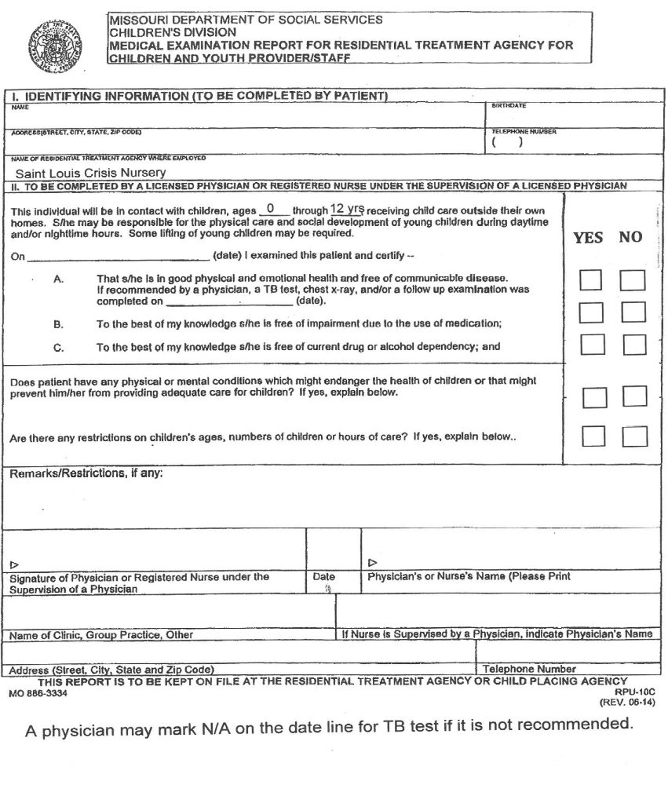
A physician may mark N/A on the date line for TB test if it is not recommended.
Yes or No must be marked for each of the 5 lines above.

Saint Louis Crisis Nursery
GUIDELINES FOR HANDLING ALL BLOOD AND BODY FLUIDS

It is important that all employees and volunteers take the necessary precautions to protect themselves from undue exposure to any blood-borne disease, including the AIDS virus (HIV) and Hepatitis B virus (HBV).

The Center for Disease Control (CDC) has established Universal Blood and Body Fluid Precautions that have been sanctioned by OSHA and will be followed by the Saint Louis Crisis Nursery staff and volunteers at all times.

The precautions as follows:

- All blood and body fluids from any individual should be considered infectious because every individual is a potential HBV and HIV carrier, and the undiagnosed case represents the greater risk of transmission.
- Hands should be washed routinely after care of the child and immediately if soiled with blood or body fluids. Hand washing may be the only precaution necessary for many child contacts.
- Gloves are required for all direct contact with blood, body fluids, or items soiled with blood or body fluids. This is especially important if the volunteer has fresh cuts or breaks in the skin. Note that gloves are not a substitute for hand washing.
- Notify staff or supervisor if supplies are needed.
Any incidences of exposure should be cared for immediately. Significant exposures include cuts or punctures of the skin; splashes onto mucous membranes (mouth) or into eyes, open wounds or lesions. You should wash the exposed area immediately with water. Scrub cuts and punctures thoroughly with soap/antiseptic solution. Flush mucous membranes or eyes with water. After completing the immediate first aid, notify appropriate Saint Louis Crisis Nursery Staff and Human Resources of the incident.
Missouri Background Check through Family Care Safety Registry
The Nursery will submit this background check for you – do not send it to the state yourself.
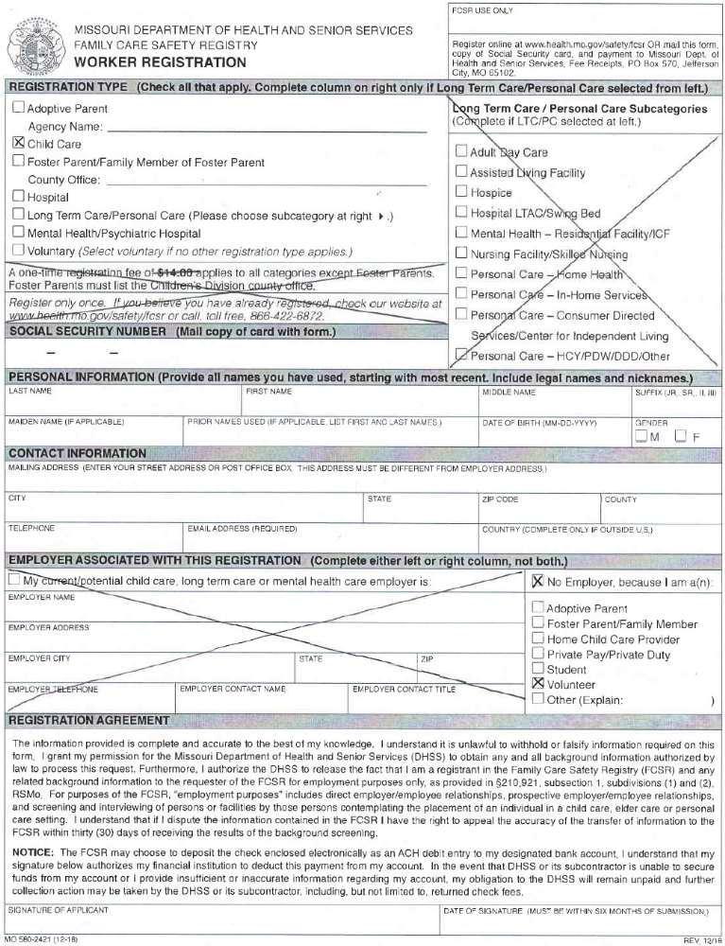
*Fingerprint Waiver – St. Louis City Centene Center Volunteers Only*
Complete and sign this waiver. The fingerprinting fee is ~$40, and you’ll pay this fee directly to the fingerprinting company. Instructions will be sent after your Volunteer Packet has been processed. Do not go to a police station to get fingerprinted.
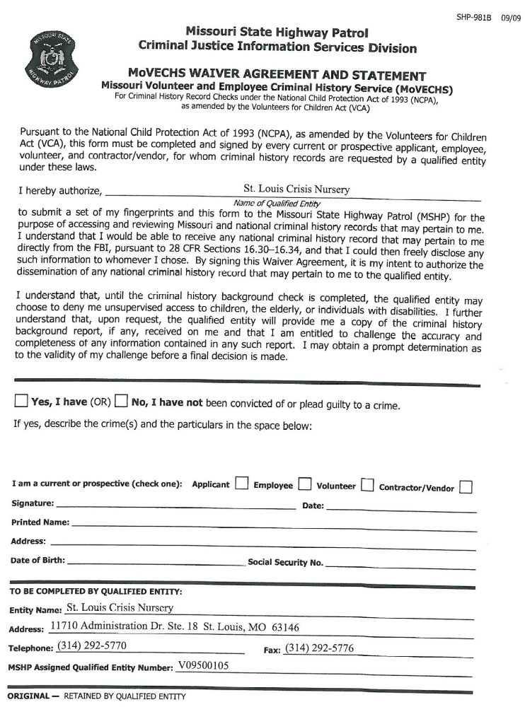

Saint Louis Crisis Nursery
Volunteer Pact

As a Volunteer, I have the RIGHT to:
- Receive a suitable assignment as well as the opportunity to choose a task from a given list.
- Receive pertinent information about the Nursery and environment within the bounds of confidentiality.
- Receive continuing education on-the-job as well as updates on new policies/procedures in a timely fashion.
- Receive sound guidance and direction by someone who is knowledgeable, patient, & well-informed.
- Be listened to and treated respectfully.
- Receive recognition for my service according to the Crisis Nursery volunteer recognition practices.

As a Volunteer, I have the RESPONSIBILITY to:
- Abide by and respect Nursery Rules.
- Adhere to the Confidentiality Agreement.
- Practice Universal Precautions at all times.
- Refrain from taking pictures or videos of the children.
- Never release names or identifying information.
- Refrain from asking the staff, children, or parents personal questions.
- Refrain from using my cell phone in the Nursery.
- Be an active volunteer, showing up for my volunteer shift as agreed and providing prompt notice if/when I am unable to present as expected for volunteer shift.
- Demonstrate concern, and attention to each child without favoritism.
- Arrange a volunteer schedule and shift that is reasonable and during a time when I am at my best.
- Be appropriately dressed for the weather and for working with children including wearing closed toe shoes, appropriate fitting shorts, i.e., walking shorts, and modest dress.
- Be positive and cooperative, taking directions willingly.
- Carry out assigned duties to the best of my ability.
- Ask questions if I am unsure of how a task is to be done.
- Consider important any task performed.
- Understand while I may not receive constant praise, my volunteer time is deeply appreciated.
- Engage in a positive manner, and practice strengths-based interaction with children.
- Track my volunteer hours for my records.

*St. Louis City Centene Center Volunteers Only*
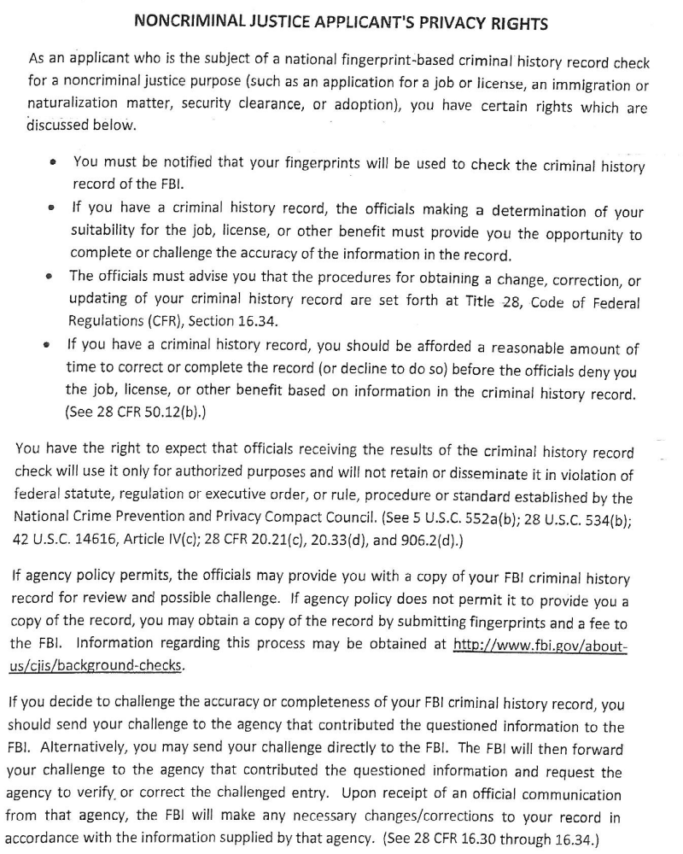
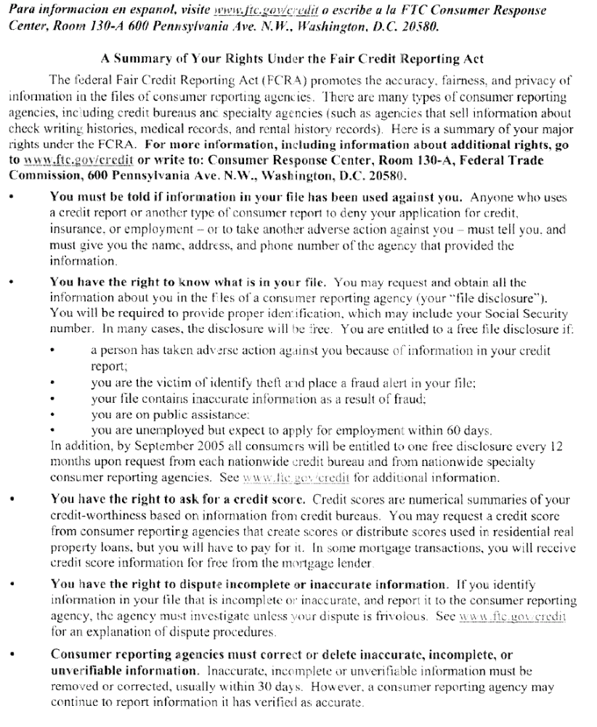
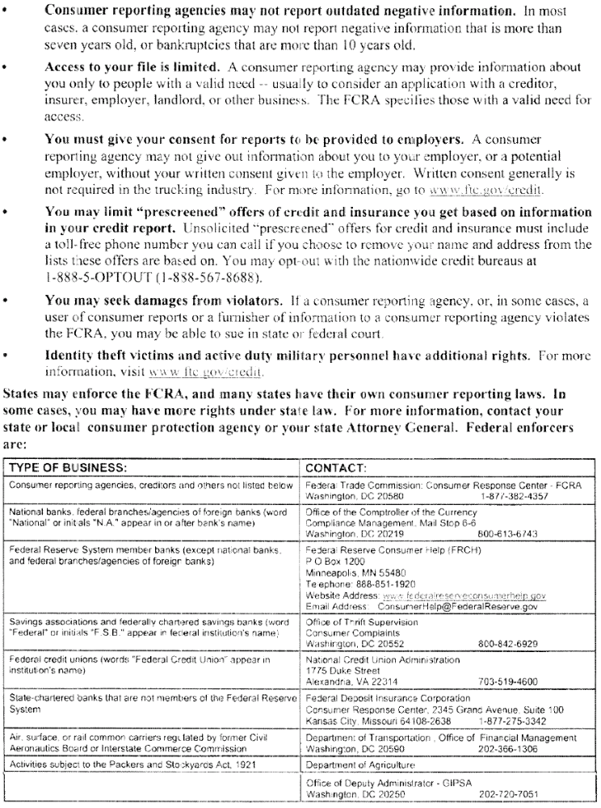


Thanks so much for your interest in becoming a Saint Louis Crisis Nursery Volunteer!
Saint Louis Crisis Nursery receives a high volume of volunteer applications, and we’re only able to consider an application when all of the required items are complete. Before submitting your Volunteer Packet, please make sure that you’ve included all of the required items listed on page 1.

Please send your completed Volunteer Packet via email, fax, mail, or by dropping it off to one of our Nursery locations, listed below. Please allow two weeks for processing. We look forward to exploring volunteer opportunities with you and will be in touch after your Volunteer Packet has been processed. Thank you!

Saint Louis Crisis Nursery – St. Louis City Centene
Maria.mulcahy@crisisnurserykids.org
Attn: Maria Mulcahy
1928 Gravois Avenue
St. Louis, MO 63104
Fax 314.338.2207

Saint Louis Crisis Nursery – North County
robin@crisisnurserykids.org
Attn: Robin Jones
11037 Breezy Point Lane
St. Louis, MO 63136
Fax 314.653.6488

Saint Louis Crisis Nursery – St. Charles
julie@crisisnurserykids.org
Attn: Julie Hernandez
315 First Capitol Drive
St. Charles, MO 63301

Saint Louis Crisis Nursery – Wentzville
Noreen@crisisnurserykids.org
Attn: Noreen Mueller
700 Medical Drive
Wentzville, MO 63385



